s

Effect of Gain in Closed-Loop Systems Position Feedback

ME4160: Control Lab - L01
Bobby B. Lyle School of Engineering, Southern Methodist University

Experiment: DATE (11/02/2018)

Submitted by
Ahmed Alfaifi

DATE
11/06/18

I, Ahmed Alfaifi, acknowledge that in preparation of the following document, I have abided by the SMU honor code (https://www.smu.edu/StudentAffairs/StudentLife/StudentHandbook/HonorCode), and the online submission of this document in Canvas represents my agreement to all consequences of violation of SMU honor code.
Objective
This experiment was carried out to illustrate the effect of gain on the response of a closed-loop system with position feedback. To achieve the experiment’s aim, the rise time, peak time, settling time, steady state error, and the percentage overshoot had to be measured. This experiment also helped in finding the difference between angular velocity and velocity.
Procedure
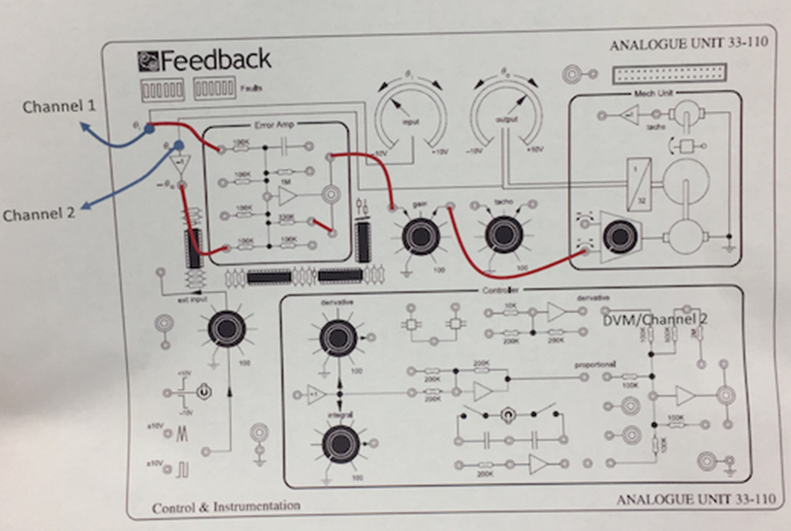
Figure 1. Closed-Loop position Control
At first the Closed-Loop position control system was set up as shown above in figure 1. The opening gain was set on diverse powers ranging between 20% and 100% full gain. Then the wire would be disengaged from the main theta and at the same time freeze the response that was showing on the oscilloscope. The angular knob was set at 90⁰ and after that; the wire would be reconnected again. At this time the rise time, peak time, settling time, steady state error, and percentage overshoot would be measured. This procedure was done repeatedly while changing the angular knob to be at -90⁰.

Results

Figure 1: shows Rise time against gain

Figure 2: shows peak time against gain

Figure 3: shows settling time against gain

Figure 4: shows percent overshoot against gain
Discussion
The results shown above indicate that the percentage shoot of the positive angle starts and ends up being higher than the negative one. The reason why the wire is disconnected instead of turning off the angular knob is to avoid abrupt change which is prone to occur when the knob is rotated from 0-90.

Answers for Questions
- Figure 1
- The closed loop systems are more reliable as they have a feedback from output signal and an open loop control system acts completely based on input and the output has no effect on the control action.
- For protecting the sharpness of the curve
- According to the results, the 0 to -90 input is the most reliable in most cases.
Conclusion
This experiment enhanced my knowledge about the effect of gain on the various responses with respect to the rising time, the peak time, the settling time, the percent overshoot, and the steady-state error. The variations of those parameters with the gain were studied and analyzed as presented in the graphs. Based on the results of the experiment we draw a conclusion that 0 to -90 input system is the most reliable system. This is because its responses provide the expected ideal curves.
Appendix 1: Raw Data
Table 1: Raw data gathered in the lab

 | Gain | Rise Time (s) | Peak Time (s) | Settling Time (s) | Steady State Error (V) | Percent Overshoot (%)
0 to 90 | 20 | 2.04 | 3.44 | 3.44 | 0 | 6.5
0 to 90 | 40 | 0.94 | 1.76 | 2.845 | 0 | 8.8
0 to 90 | 60 | 0.34 | 0.88 | 3.66 | 0 | 39.1
0 to 90 | 80 | 0.28 | 0.78 | 4.3 | 0 | 65.6
0 to 90 | 100 | 0.26 | 0.72 | 4.64 | 0 | 52.6
0 to -90 | 20 | 0.84 | 1.76 | 2.7 | 0 | 15.1
0 to -90 | 40 | 0.44 | 1.08 | 3.36 | 0 | 27.9
0 to -90 | 60 | 0.28 | 0.8 | 3.96 | 0 | 41.2
0 to -90 | 80 | 0.2 | 0.68 | 4.2 | 0 | 48.5
0 to -90 | 100 | 0.2 | 0.64 | 4.24 | 0 | 46.5

References
Instruction manual lab 4

